Project 3 Rough Design

Group 3: Pictorial Building Blocks

Brian McCarthy, Alex Titus, Jules Voltaire,

Ian Vossoughi, Adam Moran, Patrick Polley

Concept Scoring Matrix**:**

**Attributes:**

|  |  |  |
| --- | --- | --- |
| **Attribute #** | **Name** | **Description** |
| **1** | **Icon arrangement density** | Icons are grouped together in a logical, organized fashion that allows for quick and distinct access to any desired one, while not overwhelming or confusing the user with an excessive amount of icons on the screen at one particular time |
| **2** | **Cultural universality** | Icons and the general layout of the interface are designed to be understandable and appealing to users of all backgrounds and cultures, not particularly favoring one group or ethnicity over another in usability |
| **3** | **Background/foreground contrast** | All interactive objects are easily distinguishable from the background features, with sharp contrast that is clearly visible for all users (including those with poor eyesight) |
| **4** | **Menu/icon contrast** | Users can easily distinguish between selectable icons or buttons and other types of menus, in order to intuitively select particular options based on the appearance of the objects alone |
| **5** | **Ease in adding and removing icons** | The ease in repeatedly selecting icons to add to a sentence and removing unwanted icons from the partially-built sentence. As the most frequent subtask, users should be able to perform this most readily and intuitively in order to seamlessly use the interface for communication |
| **6** | **Ease in connecting icons** | Grouping together related icons to provide an overall semantic meaning to the sentence should be performed logically and intuitively, and the method for doing so should be clear to the user from the outset |
| **7** | **Ease in creating and deleting sentences** | As the first subtask and the one performed if the user wishes to start over, adding a new sentence or deleting an existing one should be readily apparent and accessible when moving from the icon selections. There should also be a prompt to ensure that the user does not accidentally delete their entire sentence with an undesired press of a button |
| **8** | **Mobility in changing selections** | Users, especially those with muscular disabilities, should be able to make selections and change between the different parts of the interface with minimal hand movement, using clear and easy motions that require little undesired actions (such as excessive scrolling or very small buttons) |

**Scoring Matrix (ratings based on a scale from 1 (worst) to 10 (best)):**

|  |  |  |  |  |  |  |  |
| --- | --- | --- | --- | --- | --- | --- | --- |
|  | | **Design 1** | | **Design 2** | | **Design 3** | |
| **Attribute** | **Weight** | **Rating** | **Score** | **Rating** | **Score** | **Rating** | **Score** |
| **1** | **0.145** | **7** | **1.015** | **6** | **0.87** | **8** | **1.16** |
| **2** | **0.175** | **4** | **0.7** | **10** | **1.75** | **10** | **1.75** |
| **3** | **0.085** | **8** | **0.68** | **9** | **0.765** | **9** | **0.765** |
| **4** | **0.105** | **8** | **0.84** | **7** | **0.735** | **8** | **0.84** |
| **5** | **0.175** | **6** | **1.05** | **8** | **1.4** | **5** | **0.875** |
| **6** | **0.125** | **2** | **0.25** | **4** | **0.5** | **4.5** | **0.5625** |
| **7** | **0.085** | **7** | **0.595** | **9** | **0.765** | **9** | **0.765** |
| **8** | **0.105** | **4** | **0.42** | **6** | **0.63** | **5** | **0.525** |
| **Total Score** | |  | **5.55** |  | **7.415** |  | **7.2425** |
| **Rank** | | **3** | **1** | **2** |

**Rationale:**

We chose not to include a scoring metric for the clarity of the icons themselves because we believe that the specific icon designs are not specific to any one general or rough layout design, but could be specified later in the design process once a broad layout was chosen.

Design 1 (Jules and Adam):

Sentence demonstrated below: The strong man threw the football far to the tall tree.

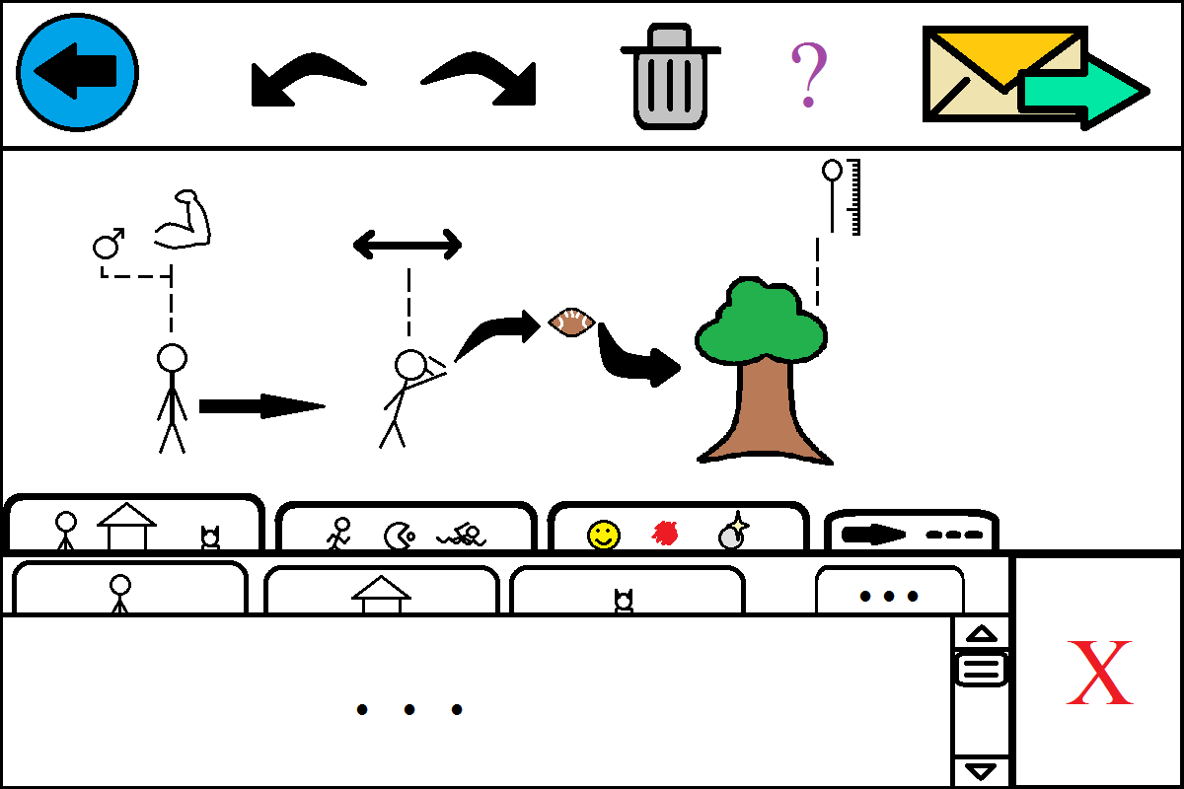

* Keyboard-based selection of icons
* “Textbox” of sentences, with a linear arrangement of the icons
* Include horizontal arrows to connect nouns and verbs, vertical dotted lines for nouns and adjectives
* Button included to reverse the arrangement of icons (to allow right-to-left and left-to-right readings)
* Different ways to cycle between categories:
  + Icon-based buttons
  + Arrow buttons that switch categories
  + Scrollbar at the bottom, with icon jumping
* How to differentiate direct-object vs. adjective modifications

Scoring notes: Design 1 was considered to be the overall worst design for the application. Its clear hierarchical structure (attribute 1) was separated by objects, actions, and descriptors, each with their own subcategories, providing greater icon arrangement density and menu/icon contrast. However, its organization was inherently flawed due to a lack of cultural universality because the icons would be added in a line to form a sentence from left to right (attribute 2). One strength of this design was the clear distinction between the background and the foreground because of the thick outlines on all the tabs and the menus (attribute 3). The other strength this design had was the clear contrast between the different tabs and the content that each contained. It should be easy for the users to learn what each tab contained and easily differentiate between different menu and icon functions (attribute 4). Unfortunately, this design was somewhat unclear in terms of how the user should go about deleting segments of the sentence. This was mostly due to the ambiguous design of the X button and what it could be used to delete (attribute 5). Another problem was the fact that this design made it extremely unclear for connecting attributes and icons. Specifically, the user would have to intuit that the descriptors could be dragged onto the existing icons. Another problem was that there would be an upper limit to the number of descriptors a user could apply to an object without having those descriptors overlap with each other on the display (attribute 6). Although it seems relatively clear how one would create and delete segments of the sentence, the user would need to learn that it is possible to drag icons onto each other in order to create connections. This seems challenging to intuit (attribute 7). Finally, this design was lacking because of the density of tabs and icons. For the elderly, who might not be able to select small icons with ease, it would be very challenging to accurately select which tab they wanted to go into. Because the tabs were so small and so close to each other, accurate selections would require dexterity. This is not something we can assume our user base has (attribute 8). This problem would be made worse from the fact that the design uses a hierarchical tab system. The user might select the wrong tab on their current level, or the wrong tab on a higher or lower level of the hierarchy.

Design 2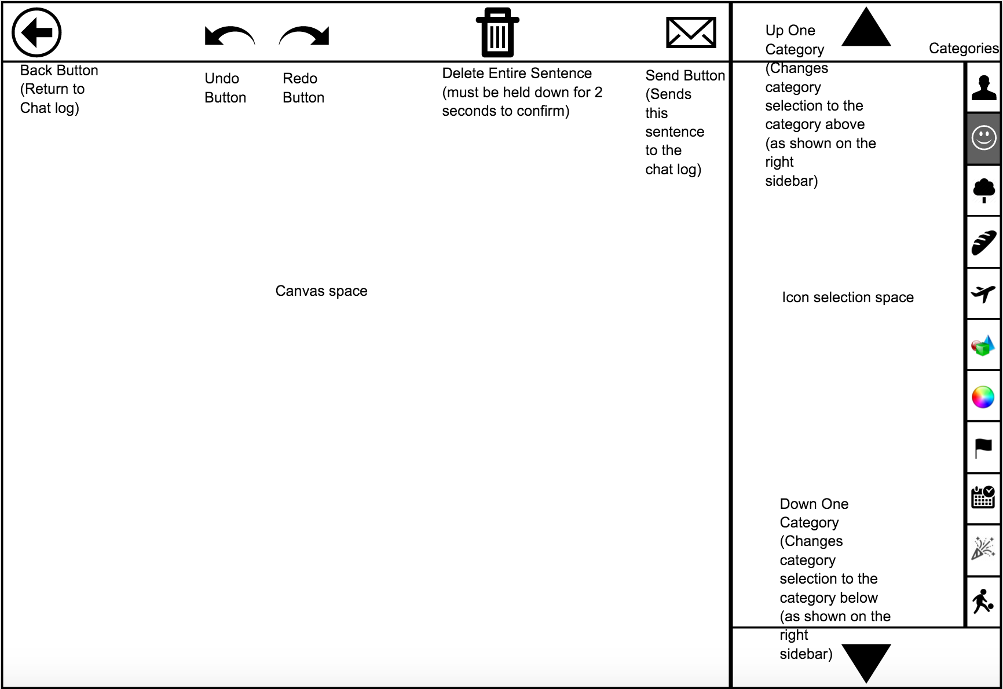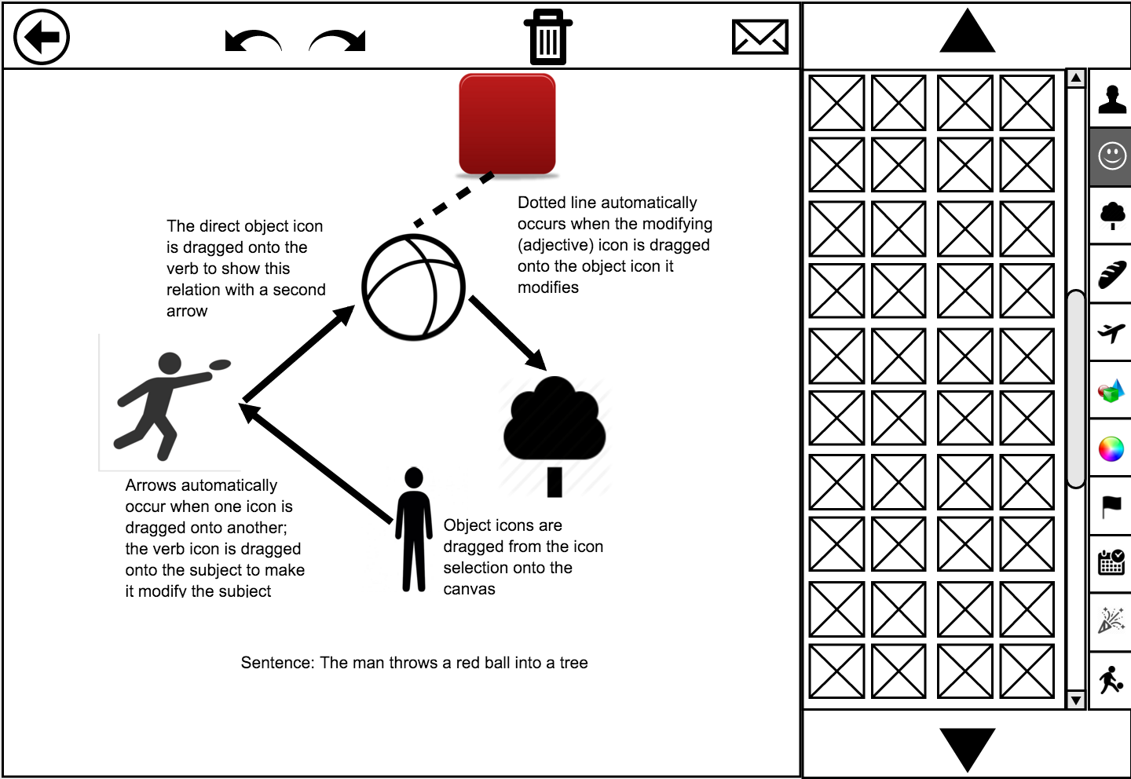

* Canvas-based design, drag icons from box onto the page and arrange them as they wish
* Using arrows and dotted lines to convey connections
* Automatic built-in arrows: as you drag modifying icons onto object icons, they will arrange by themselves
* Radial based arrangement of icons on the canvas, freely adjustable by the user
* Delete icons by dragging them out of the canvas (into the icon category)
* Delete entire sentence with a trash can button
  + Holding-based deletion confirmation
* Click on an arrow to reverse it in case of mistake
* Icon category can be changed via up and down buttons, sidebar to quickly access the categories
* Back button to return to the chat log
* Undo/redo buttons above canvas
* Retain the canvas objects when you’ve pressed Back to review what happened in the chat log

Scoring notes: The sidebar layout, especially the menu selections, was found to be intrinsically dense (attribute 1), but it was determined that the arrangement of the icons as displayed in the design could be changed to make it less dense by changing the size of the icons and the number of icons per row. The adjustable, arrow-based design of “sentences” was determined to make the message as culturally universal (attribute 2) as possible. The contrast between background and foreground (attribute 3) was not found to be a major issue, but it was difficult to measure this attribute because of the roughness of the design. Almost all things displayed on the screen in this design are selectable, though the menu could be mistaken as a non-selectable status indicator rather than a quick-jump feature. This impacted the menu-icon contrast (attribute 4), as did the relatively small size of the category buttons in the menu. Adding and removing icons (attribute 5) occurs rather seamlessly, with the “bin” of selectable icons on the side serving as an intuitive metaphor for accessing the desired icons via a drag-and-drop motion; however, this may tire the user and produce wear upon the hand when used excessively. Similarly, removing icons by dragging them back into the bin is a simple and understandable action, although the final design should include some sort of indication on the icon selection space to directly demonstrate this movement the user. A major criticism of Design 2 was the difficulty in determining how to connect icons that have already been placed on the canvas (attribute 6), specifically the process of dragging one onto another to form arrow-based connections. This process is rather non-intuitive. However, unlike Design 1, the automatic creation of arrows/dashed lines will ensure consistency in the types of connections. Deleting an entire sentence (attribute 7) is simple and clear for the user, with the trash bin button being placed in the top menu bar to indicate its importance. Additionally, requiring a 3 second hold on the button to erase the sentence, during which the icon will gradually fade to black, would allow a confirmation of the user’s intent, reducing the mistakes made. The large amount of scrolling involved with selecting icons, due to the broad categories they are placed in, has led to Design 2 lacking somewhat in selection mobility (attribute 8). However, the only menu that the user must navigate is the icon category selector, meaning they can rapidly place multiple icons of differing types with only a few clicks by changing the category using the sidebar buttons or the “change category” buttons at the top and bottom.

Design 3 (Brian and Patrick):

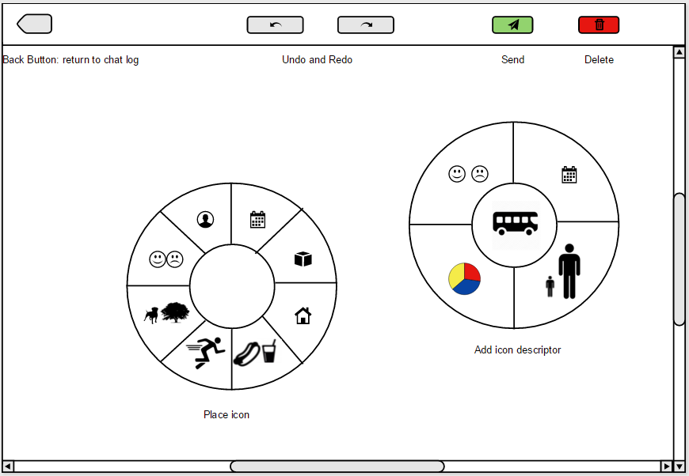

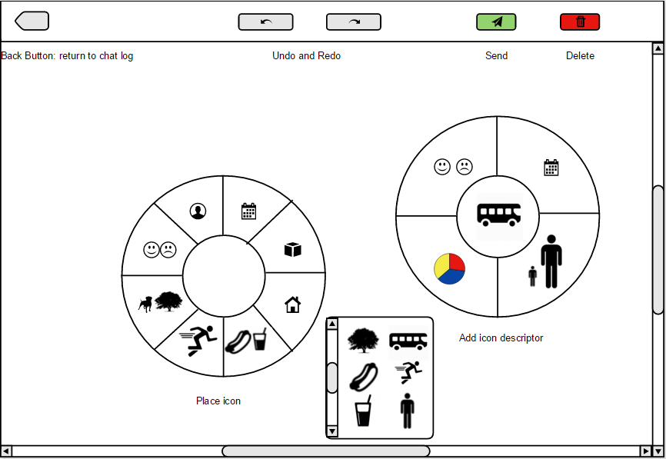

* Canvas design similar to #2, but strictly object-oriented
* Canvas fills almost entire screen
* Drag objects onto the canvas, then tap them to find an adjective icon to modify them
* Drag one object onto another to access verbs that associate between the two of them
* Pie menu appears upon tapping an object (adjectives), tapping on a blank space (noun), or dragging one object onto another (verbs)
* Icon selections appear in small pop-up window right next to the pie menu
* Undo, redo, send, delete buttons on a top bar
* Arrows are automatically placed once the user selects a modifying icon
* Click on an arrow between a noun, verb, and other noun to reverse the direction (and therefore modification)

Scoring notes: The pie menu layout allowed for the best icon density between the 3 designs (attribute 1); The extra pop-up menu for each category of icons only needed to fit a small number of icons. Because it did not have a fixed location, the icons could be spread out as much as needed. The canvas layout and arrow-based design resulted in high cultural universality, similar to design 2 (attribute 2). It was hard to determine an exact measurement of background/foreground contrast from the rough design, but we determined that it would not be a major issue in this design (attribute 3). The menu/icon contrast also scored highly for this design (attribute 4), because the pie menus were easily distinguishable from the rest of the canvas. However, this design would provide the users with an inherent difficulty in understanding how to place and remove icons (attribute 5) because the pie menus are not visible until the user clicks in the canvas. The user would not necessarily know how to add icons unless shown with an example. However, once the user saw how to access the pie menus, it would be easy for them to add and remove icons and attributes, simply because the pie menu allows for quick and easy browsing of all of the options. Similar to design 2, connecting icons would not be intuitive for first time users (attribute 6). However, this is slightly mitigated by the system automatically handling adjective/noun connections for the user. Deleting sentences (attribute 7) is functionally identical to how a user would delete sentences in design 2, and therefore was rated equally. Mobility in changing selections (attribute 8) would be easy for experienced users, due to the inherent advantages of pie menus. However, if a user opened up a specific category of icons and then wanted to choose another category, they would have to close the current menu and then open a new category-selection menu. This means that it would require an extra user input compared to the other 2 designs.